CRM Project

Functional Specification - Enhancement

PP6

(PP6) CM-090-150-040-E.CM_ENH_390 Contract Mgt End Contract Notification
(CM_ENH_390)

Deliverable Name | (PP6) CM-090-150-040-E.CM_ENH_390 - Contract Mgt End Contract Notification
Date | 11/1/2010
Revision | V1.0
Signed off By | Functional lead/PP6 Owner
Signoff Date

TABLE OF CONTENTS

1. Version 3
2. Approvals 4
3. Priority Mention the Priority of the object from the FRICEW list in ILM. N/A Processing Mode (check all that apply) 4
Low Medium High 4
4. Enhancement Requirements Description 4
5. Impacted Systems 5
6. Approach to be followed < List the type of enhancement whether it is a user exit, BADI or Custom transaction> 5
7. Roles and Volumes 5
8. Security & Control Requirements 5
8.1. Security Requirements 6
8.2. Control/Audit Requirements 6
9. Dependencies 7
9.1. Development Dependencies 7
9.2. Run/Execution Dependencies 7
9.3. Archiving Dependencies 7
10. Execution Steps 7
10.1. Process Description 8
10.2. Process Flow 8
10.3. As-Is Systems Referred To 8
10.4. Processing Options 8
11. Enhancement Description 9
11.1. Detailed Description of the Enhancement 9
11.1.1. Notifications – Pre Process 9
11.1.2. Scheduling 16
11.1.3. Notifications – Post Process 19
11.2. UI Design and Screen Flow < Mention the WEBUI Design in the sense the mock up screens and the navigation flow between the screens etc> 20
11.3. Access Method or Path for Enhancement 20
11.4. Required Custom Tables (if known) 20
11.5. Error Handling Rules 21
12. Enhancement Reconciliation & Testing Requirements 21
12.1. Data Validation 21
12.2. Testing Reconciliation 21
12.3. Performance Issues 22
13. Additional Information 22
14. Open Items 22
15. Functional Unit Test cases <Here they should list the possible test scenarios in the table below> 22

Version
Ensure that any approved change requests that affect scope are documented in the revision history and include CR #.
Version | Change Description | Author | Date Released | Sections Impacted
Enter in the version number | Brief description of the change | Who made the change | Date change was made | Mention the sections impacted with this change
1.0 | Creation | J Jarone | 11/15/2010
1.1 | Post Business Review | JJarone | 11/30/2010
1.2 | Update Cancel Process message | JJarone | 12/23/2010
1.3 | Update Development ID | JJarone | 12/27/2010
1.4 | Add suggested updates from developers | JJarone | 01/06/2011
1.5 | Cancel Process update | JJarone | 2/1/2011
1.6 | Change Request CHG03917 updates. Process framework Traffic Light logic described for system messages | JJarone | 5/9/2011 | 11.1.2.1 (pg and 11.5 (pg
1.7 | Change Request CHG03955 Restrict the Cancel Notification candidates to Notification Types of D2 and D3  Change Request CHG03953 Owner Refuses Service forcing Disconnect | JJarone | 5/17/2011 | 11.1.1.2 (pg 12,14,21
1.8 | Change Request CHG04357  Remove requirement to navigate to the Address Maintenance View upon Submit/Cancel the Notification process  Change Request CHG04360  Update Landlord Refuses service logic to force a disconnect. | J Jarone | 10/18/2011 | 11.1.2.1 (pg 19)  11.1.1.1 (pg 12)  11.5 (pg 21)

Approvals
The individuals listed below will be required to review and approve this document.

Reviewers Title | Reviewer Role | Name
Project Title of Reviewer | Reviewer's Role (Responsible, Approve, Consult, Inform) | Reviewer's Name
Functional Lead | Approve | Robert Smeltekop
Development Lead | Approve | V Krishna Karunakaram
Business Owner | Approve | Anita Jackson
Business Owner | Approve | Diane Couture
Business Owner | Approve | Corey Williams

Priority
Mention the Priority of the object from the FRICEW list in ILM.
N/A
Processing Mode (check all that apply)

Low Medium High

Enhancement Requirements Description
<This section should contain a detailed description of the business requirements for this enhancement in business terms. Please insert any description of the business flow which would aid in understanding this process.>
This enhancement is one of four sub processes to be developed within the End Contract process framework. The processes are as follows, Contract & Meter Data, Notifications, Address Maintenance, and Summary, figure 4.1. This enhancement, Notification, will export information required in subsequent steps within the process framework.

The user will provide the Create and Cancel notifications within this view set.

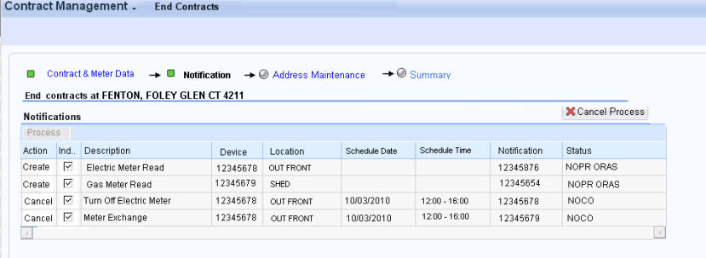
Figure 4.1

Impacted Systems
<This list should include systems that are being impacted as a result of this enhancement.>
CRM 7.0 Web IC : CRM 7.0 Web Client Interaction Center Production System
ECC 6.0 / IS-U ECC 6.0 / IS-U : Back End Production System (Enterprise Central Component)

Approach to be followed
< List the type of enhancement whether it is a user exit, BADI or Custom transaction>
Custom Transaction

Roles and Volumes
<Describe information regarding users and volumes. Make sure to note if the use of this development will require additional communication and/or training. Also, specify what the volume requirements will be needed by the Go-Live date.

Complete the table below with the correct project-specific information for this functional specification. Instructions are in the middle row, and a sample entry is in the bottom row.>

Role | Estimated Volume Requirement | Comments
List name of role; should come from the list of security roles | Enter the estimated volume requirements that will be needed by the Go-Lie date | Enter other comments including if this development will require additional communication and/or training
CSR 2, 3, 4, VCC MGMT | 1,000,000 / Year
BCOS | +- 75
Billing | +- 75
Consumer Affairs | +- 75
Revenue Recovery | +- 75

Security & Control Requirements

Security Requirements
<Describe any security requirements that need to be put in place as a result of this development object. This could include security access to affected transactions or new transactions that may result from this development. If the enhancement has to be archive enabled, list additional security to be added to the roles.>

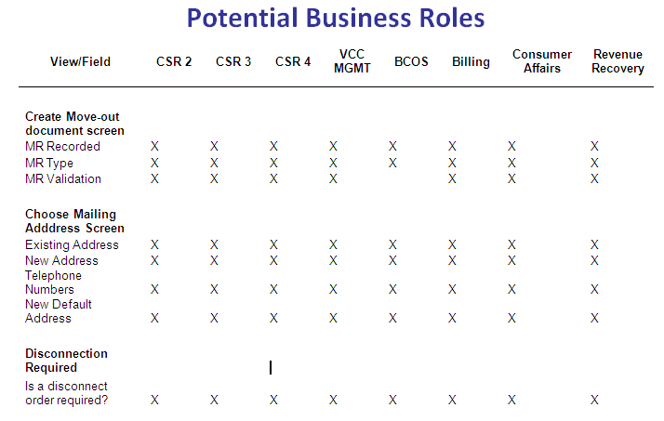
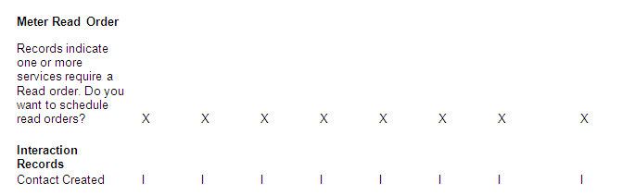
Figure 8.1.1

Security requirements will be handled through business roles. The business roles in figure 8.1.1 will have access to the End Contract process framework.

- CM-090-050-010-S Security will be handled through business Roles. The Contract Management work center will be available by business roles.
- CM-090-150-020-S - CSR business roles that perform a move-out on non-owner allocated C&I accounts should be forced to create a disconnect notification

Control/Audit Requirements
<Describe any control requirements that need to be put in place as a result of this development object>.
- If applicable, please answer the question and also provide detail to the question.
- The questions listed below are not all inclusive to the control requirement that may be required. If there are any other controls requirements please document them as well.

- Indicate if this enhancement is being developed to address a control requirement?
- Financial/SOX Impact - Does the enhancement have any impact to financial reporting? If yes, is the amount significant (i.e. greater than $35 million annually)? Please provide an estimate. No.
- Regulatory Impact - Does the enhancement have any impact to regulatory compliance (i.e. FERC, NERC, etc)? If yes, please provide a reference to the rule and describe the impact. No
- Operational Impact - Is the enhancement relied upon for a mission critical process or providing services to customers? If yes, please identify the mission critical process and describe how this enhancement is used in the context of this process. Yes, this enhancement provides the ability to create service notifications to obtain move-out meter reads. Additionally, this enhancement will enable the user to cancel service notification thus preventing unnecessary field trips.
CRM_032

Dependencies

Development Dependencies
<List the configuration, development, and other work that must be considered during the creation of this enhancement.>

Seq. | Development ID | Change ID | Description
2 | CM_ENH_290 | CM-090-150-160-E | (PP6) Contract Mgt End Contract & Meter Data
3 | SO_ENH_010 | CM-060-230-060-E | Create Orders and Notifications
4 | SO_ENH_040 | CM-060-230-310-C | Scheduling

Run/Execution Dependencies
<Once in production, this development object may need to be executed before or after another system event. List other system events that this development object should follow or precede. If the enhancement is to be archived enabled, does it need to have adequate archived sessions, info structures, etc established in order to test/execute.>

Business Partner and Premise must be confirmed.
User must have been presented the Contract & Meter Data view within the End Contract Process Framework.

Archiving Dependencies
<List how the changes would impact archiving, if the enhancement impacts existing archived objects (i.e. table structures). Also list what needs to be regression tested from an archiving perspective.>

N/A

Execution Steps
This process may be accessed in two ways:
- A user may click directly on Contract Management Work Center and select the End Contract button
- A user may select the submenu from Contract Management Work Center, and select the End Contract (This will be the Best Practice method)
- The Contract & Meter Data View Set was presented to the user. End Contract Date was applied.

Process Description
<Explain the process for when this development object will be used. If this is tied back to a certain task within a process you may insert the Task Profile document here as well.

Enter any of the following information available:
- Transaction Code
- User Exits
- Performance Consideration
- Z Tables created
- Code reuse.
New Enhancement / ECC Code reuse

Process Flow
<Create a diagram that visually depicts the process.>
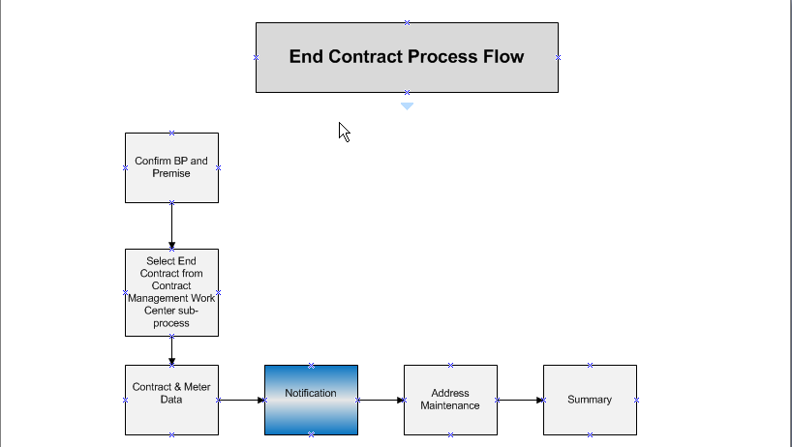

As-Is Systems Referred To
<List the systems that the task pertaining to this development object is performed in. If this is a new task (i.e. not being performed today), list it ‘Not applicable’.>

This task is currently performed in the Move-Out FOP

Processing Options
<Indicate the Processing Mode, Frequency, and Lifetime of Development by selecting and placing an ‘X’ in the box next to the correct options below. Right click on the gray box, select properties, and specify “Checked”.>
Processing Mode (Select one of the following)
Batch Online – via Transaction Code Online – via Menu Path
On demand

Frequency (Select one of the following)
Daily
Weekly Quarterly
Monthly Annually
Other (If other, describe here) On Demand

Lifetime of Development (select one)
Permanent
Temporary, e.g. until rollouts are complete, specify details here

Enhancement Description
<Provide a brief description of the enhancement.>
The End Contact process framework has been broken into individual units of work that must share data when configured as a whole. This development will need access to the results of the Contract & Meter Data enhancement. This development will export data to the Summary development.

This document will describe the enhancement in 2 sections. Section 1 will describe the requirements for creating and canceling notifications. Section 2 will describe the Notification creation and scheduling process.

Detailed Description of the Enhancement
<Provide a written description of the functionality that needs to be developed. Identify/describe the SAP application transaction that uses or is used to invoke the enhancement. Describe tables, transactions, reports, forms, screens and other objects that need to be created or modified. Insert a Visio flow diagram of the process to be executed by the enhancement, and add any other information required to develop the enhancement.>

This enhancement view will allow the agent to create notifications to support the End Contract process. To avoid unnecessary field trips this view will allow the agent to cancel open notifications thus preventing follow up calls from an inconvenienced customer. The creation and/or cancellation of notifications will not always be necessary therefore the system should disable the Notification step within the process framework if no notification requirements exist.

Detailed below is detailed ECC logic currently in place. It will be up to the developer to determine the best technical approach to obtain the desired attributes.

- Import
  - Contract & Meter Data – Meter Read Result.
  - Contract & Meter Data – Contract Selection List
  - Contract & Meter Data – Contract End Date
- Export
  - Notifications Created
  - Notifications Canceled
  - Notification Schedule Date
  - Notifications Scheduling Customer Information Text

Notifications – Pre Process
The Notifications view will be used to create notifications and allow the user to cancel open notification preventing unnecessary field trips. The system should disable the Notification step if no notifications exist for creation or cancellation.

The Action Indicator will be unmarked except under certain conditions when a disconnect notification is mandatory. If the user marks the Action Indicator then the user must process the Notification actions or uncheck the action indicator before being allowed to Submit the End Contract. Display message 020 Error Message ‘Outstanding Notification Action(s) exist.

Notification types that can be created during the End Contract process are Disconnect and Meter Read orders. Only 1 type of notification will be created therefore, if the user, for example, requests a disconnect order then the system should disable the meter read notification type.

Notifications Structure
Field | Value | Display
Process | Enabled | Yes
Action | Create or Cancel | Yes
Indicator | Default UnMarked | Yes
Description | Notification Code Description | Yes
Device | Device associated with installation | Yes
Location | Device Location Location | Yes
Schedule Date | Notification Schedule Start Date | Yes
Schedule Time | Notification Schedule Start Time | Yes
Notification | Notification Number | Yes
Status | Notification System Status | Yes
Contract End Date | New Contract Start Date | No
Update End Date | Update End Contract Date Indicator | No
Order Code | Create Action Order Code | No
Installation | New Contract Installation | No
End Contract BP | Confirmed BP | No
Notification BP | Open Notification BP | No
Process Complete Code | S – Successful completion  E - Error | No

      - Notification Creation Determination
To determine if a Notification should be Created or Canceled perform the following checks in sequence.

Listed below are all the possible order codes for the End Contract Notification process
Order Code | Description
ZTFE | TURN OFF ELECTRIC METER
ZTFG | TURN OFF GAS METER
ZREE | READ ELECTRIC METER
ZREG | READ GAS METER

- Check for Device
  - To determine if a meter exists for the installation use the installation to retrieve property ZINSTLN.zCurrentDevices. If no devices exist, then no notification will be created.

- Check for Disconnect
  - To determine if the installation is disconnected, use the installation get value of attribute ZINSTLN. DisconnectionStatusNew.
If value = 01 then the installation has a pending disconnect. – Do nothing. The check for open notifications should allow for cancellation of any open notifications.
If value = 10 then the installation is already disconnected – Do Nothing. No notification will be created.
If value = 00 then prompt for the creation of a Disconnect Order.

- Check for Owner Allocation on the premise by attribute ZPREMISE. ZPropertyOwnerAlloc. If the attribute = X then check if the business partner moving out is the same as the property owner. Attribute ZPREMISE. ZPropertyOwnerNumber will return the property owner’s number. If the BP numbers are the same then check if Create Event flag is marked on the property (EPROP~ ACBACT = X). If all of the above is true then disconnection is mandatory and the action indicator should be marked and disabled. Add record to the display table – Mark ‘Update Contract End Date’ Field. Meter read notification creation will not be allowed. Display Message 060 Owner Refuses Service Disconnection is Mandatory
- Check for Owner Allocation on the premise by attribute ZPREMISE. ZPropertyOwnerAlloc. If the attribute = X then check if the Create Event flag is not marked on the property (EPROP~ ACBACT = Null). If all of the above is true then disconnection is mandatory and the action indicator should be marked and disabled. Add record to the display table – Mark ‘Update Contract End Date’ Field. Meter read notification creation will not be allowed. Display Message 060 Owner Refuses Service Disconnection is Mandatory

- Check for Multi Dwelling indicator using method Premise.ZMULTIDWELLALERT. If the MULTIDWELLINDICATOR = X then Display Message 030 Warning Message ‘Multi Dwelling Premise, disconnection strongly recommended. Mark the Action Indicator field and add record to the display table – Mark ‘Update Contract End Date’ Field.
- Check for C&I premise. Select the product associated with the contract and retrieve the billing class. If the billing class <> RES then it is a C&I account. Using the end contract date + 1, check for owner allocations using ZPREMISE. FindOwner. If OwnerActive = X then disconnect is not required. If OwnerActive <> X and the business role = CSR2, CSR3, CSR4 then disconnection is mandatory and the action indicator should be marked and disabled. Add record to the display table – Mark ‘Update Contract End Date’ Field. Meter read notification creation will not be allowed. Display Message 040 Commercial Account NO Current Owner Allocation Disconnection is Mandatory. If OwnerActive <> X and the business role <> CSR2, CSR3, CSR4 then disconnection is recommended. Mark the Action Indicator field and add record to the display table – Mark ‘Update Contract End Date’ Field Display Message 050 Commercial Account NO Current Owner Allocation Disconnection is strongly recommended.

- If the Multi Dwelling and C&I checks failed then add record to the display table – Mark ‘Update Contract End Date’ Field.

  - If the installation division = 01 (electric) the order code = ZTFE
  - If the installation division = 02 (gas) the order code = ZTFG
- If meter reads for the installation was entered in Contract & Meter Data meter reading section then no further check is necessary for the installation.
  - To determine if a meter read order is necessary use attribute ZINSTLN.NOREADHIST. If NOREADHIST = X then:
    - If installation division = 01 (electric) then Order Code = ZREE - Add record to the display table. If a disconnect notification was not entered for the installation then mark the action indicator.
    - If installation division = 02 (gas) then Order Code = ZREG - Add record to the display table. If a disconnect notification was not entered for the installation then mark the action indicator
  - If ZINSTLN.NOREADHIST = Null and the installation division = -1 (electric) then check for a demand read. Using the product, get the Metering Type. If the value of the Product’s Meter Type = MTD (Metered with Demand) then:
    - If installation division = 01 (electric) then Order Code = ZREE - Add record to the display table. If the user elects to disconnect the installation then the unmark the action indicator and disable the action indicator. If the user unselects the disconnect action indicator then mark the action indicator and disable. Basically, if the installation is Metered with Demand then a disconnect order or meter read order is required.
- Populate Pre Process CREATE Display Fields
Field | Value | Description
Process | Enabled or Disabled | Enabled if any record has the Indicator marked and enabled
Action | Create or Cancel | Create
Indicator | Default UnMarked | Marked unless otherwise noted
Description | Notification Code Description | Using the Order Code retrieve the Description from TEWOCODE
Device | Device associated with installation | ZINSTLN.zCurrentDevices to retrieve the meters.
Location | Device Location Location | Use ZINSTLN.zCurrentDevices → ZDEVICE. ZDevLoc → DEVLOC-LOCATION to retrieve the device location Location value
Schedule Date | Notification Schedule Start Date | NULL
Schedule Time | Notification Schedule Start Time | NULL
Notification | Notification Number | NULL
Status | Notification System Status | NULL
Contract End Date | End Contract Date | Retrieved from Contract & Meter Data View Enhancement
Update End Date | Update Contract End Date Indicator | Derived by Notification Type. This fields will indicate if the End Contract Date should be updated based on the Schedule Date
Order Code | Create Action Order Code | Derived
Installation | End Contract Installation
New Contract BP | Confirmed BP
Notification BP | Null
Process Complete Code | Null

      - Notification Cancellation Determination
- Get Open Notifications for the device Location
- Determine if a meter exists for the installation using the installation to retrieve property ZINSTLN.zCurrentDevices.
  - If ZINSTLN. zCurrentDevices <> Null then a meter exists. Get the device location associated with the meter using ZDEVICE.ZDevLoc
  - If ZINSTLN. zCurrentDevices = Null then a meter does not exist. Get the device location associated with the installation:
    - If division is 01 (Electric), using the attribute ZPREIMISE.ELECTRICDEVLOC
    - If division is02 (Gas), get the device location using the attribute ZPREMISE.GASDEVLOC.
  - Get the functional location to be used in the open notification look up. SELECT iloan
FROM iloa
WHERE tplnr = device location
AND owner = '4'. "notification
  - Get the Open notifications where the location reference object is equal to the device location.
SELECT qmnum qmtxt strmn kunum objnr FROM viqmel
WHERE iloan =functional location
AND qmart in (D2, D3)
AND qmdab = '00000000'
AND strmn >= system date – 1 year.

- For each open notification found, get the status of the using FM
CALL FUNCTION 'STATUS_TEXT_EDIT'
EXPORTING
client = sy-mandt
objnr = p_objnr
only_active = 'X'
spras = sy-langu
IMPORTING
line = p_sysys.
- Populate Pre Process Cancel Display Fields

Field | Value
Process | Enabled or Disabled | Enabled if any record has the Indicator marked and enabled
Action | Create or Cancel | Cancel
Indicator | Default Marked | Marked
Description | Notification Code Description | VIQMEL~QMTXT
Device | Device associated with installation | ZINSTLN.zCurrentDevices to retrieve the meters. This field will be null for install orders
Location | Device Location Location | Use ZINSTLN.zCurrentDevices → ZDEVICE. ZDevLoc → DEVLOC-LOCATION to retrieve the device location Location value
Start Date | Notification Schedule Start Date | VIQMEL~STRMN
Schedule Time | Notification Schedule Start Time | VIQMEL~STRUR – VIQMEL~LTRUR
Notification | Notification Number | VIQMEL~QMNUM
Status | Notification System Status | Using VIQMEL~OBJNR call FM 'STATUS_TEXT_EDIT'. Display Line value
Contract End Date | End Contract Date | Retrieved from Contract & Meter Data View Enhancement
Update End Date | Update End Contract Date | Derived by Notification Type. This fields will indicate if the End Contract Date should be updated based on the Schedule Date
Order Code | Null
Installation | New Contract Installation
New Contract BP | Confirmed Business Partner
Notification BP | Open Notification BP | VIQMEL~KUNUM
Process Complete Code | Null

      - Cancel Process
If the user decides to cancel the process by selecting the ‘Cancel Process’ button then the confirmation dialog popup should be displayed. If the user confirms cancellation then the Factsheet View should be displayed and the Interaction Record updated with:

➢ Interaction Record Note– Write to the Interaction Record.
- APP ID: CMCRNC
- Message: “End Contract Process Cancelled”

If notifications have been create prior to selecting the Cancel Process button then display the follow:

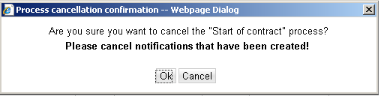

If no notifications have been created display the following:

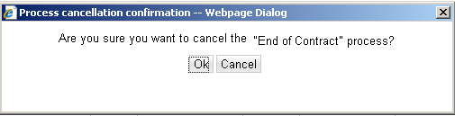

Scheduling
Once the user selects the Process button, the user will be presented with views developed in CM-060-230-060-E SO_ENH_010 Create Orders and Notifications and CM-060-230-310-C (SO_ENH_040) Scheduling to create and schedule notifications. Cancellation of orders will be performed in the background with long text “Cancellation due to End Contract Creation” entered as the cancellation reason.

The following information will need to be need passed to process notifications and returned once processing is complete.

Field | Value
Action | Create or Cancel | Return as is
Indicator | Marked | If user does not create a notification then return the field as unmarked – Under the C&I account scenario the notification creation is mandatory.
Description | Notification Code Description | Return as is
Device | Device associated with installation | Return as is
Location | Device Location Location | Return as is
Schedule Date | Notification Schedule Start Date | Return Create Schedule Date
Schedule Time | Notification Schedule Start Time | Return Create Schedule Time
Notification | Notification Number | Return as is if Cancel Action  Return Notification Created
Status | Notification System Status | Return as is
Contract End Date | End Contract Date | Retrieved from Contract & Meter Data View Enhancement – Return as is
Order Code | Order Code for the Create Process | Return as is
Premise | Confirmed Premise | Return as is
Installation | New Contract Installation | Return as is
New Contract BP | Confirmed Business Partner | Return as is
Notification BP | Open Notification BP | Return as is
Process Complete Code | S = Success  E = Error | Return code
Return Message | Message text | Return error message for display
Long Text | Notification Long Text entered by the user

      - Notification Creation Process Flow
Consistency is key to the views and processing between the End Contract Notification and the Create Service order and Notification Scheduling views. Below are screen shots of the Create Service Order enhancement with minor modifications when called within the End Contract process framework.

Clarifying Questions – Assignment Block 1
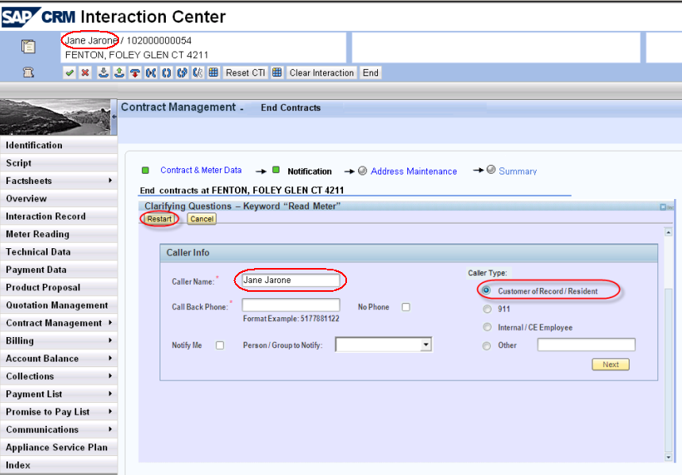

- Default Caller Type to “Customer of Record/Resident
- Hide the Restart Button
- If the user selects the Cancel button, then return to the Notification Step.
- Default the Caller Name to the confirmed BP name as displayed in the identification confirmation area

Clarifying Questions – Assignment Block 2
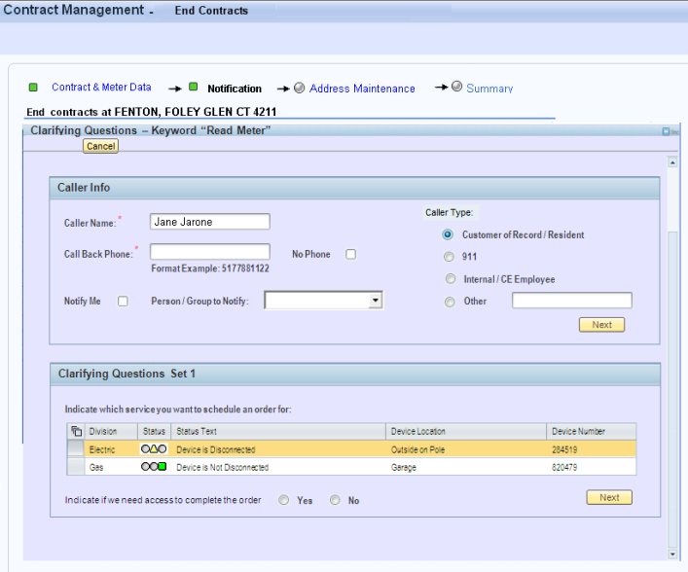
- Select all orders for Creation and scheduling. If order types are different then select the first row. The user will then have to select the rest rows to create the orders. When notification creation is mandatory the user will not be allowed to unselect the row.

Scheduling View
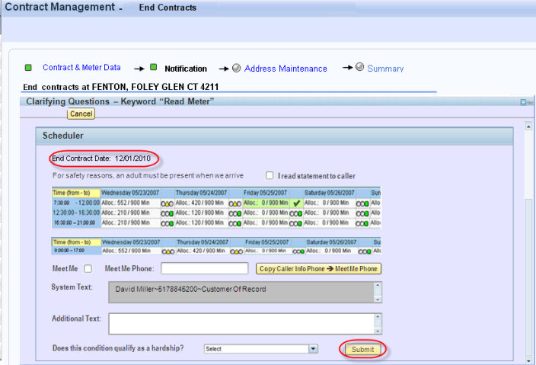
- Display End Contract Date
- Submit –
  - If the End Contract date <> the notification schedule date and the Update End Contract Date is marked then update the End Contract date to match the schedule date. Meter Read orders of 03 will be updated to equal the End Contact date.
  - Upon submission of the Creation and/or Cancellation of Notifications, the user will remain on the Notification step.
  - If no error occurred and the notification number is null for a Create action then the user declined to create the order. Unmark the row to suppress error messages.
  - If an error occurred then display the message returned from the Service Order and Notification Process and display as a warning allowing the user to Submit the End Contract. The traffic light should turn Yellow indicating a warning. The user will be allowed to move off the Notification view
  - Return the long text of the notification.

Notifications – Post Process
The user may want to review the notifications processed. Disable the Process button and Action Indicator field. Display relevant fields. If any errors occurred during Notification Creation or Cancellation display the message as a warning system message.
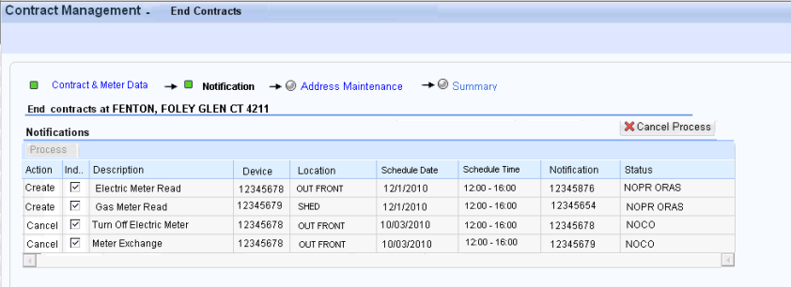

  - Interaction Record Add– Write to the Interaction Record the Notification Numbers that were created during the Notification Process
    - APP ID: CMCREC
    - Message: “Notification &1 created as &2”
    - Variable 1: Notification number
    - Variable 2: Notification Type

  - Interaction Record Add – Write to the Interaction Records for the notifications that were cancelled.
- APP ID: CMCREC
- Message: “Notification &1 canceled.”
Variable 1: Notification number

UI Design and Screen Flow
< Mention the WEBUI Design in the sense the mock up screens and the navigation flow between the screens etc>

See section 1.1.1 for Screen flow

Access Method or Path for Enhancement
<Select the correct execution path below by placing an ‘X’ in the checkbox next to it and completing the description that follows. Check all that apply and add any other execution methods if required by the Client. Right click on the gray box, select properties, and specify “Checked”.>
Execution: Custom Transaction Code:
Menu Path:
Standard Transaction Code:
Other: CRM 7.0 Web IC Navigation

Required Custom Tables (if known)
<Provide any information about custom tables required for this enhancement.>
N/A
Table Name: Enter Table Name
Table Description: Enter Table Description
M/O | Field Description | Type (text or numeric) | Maximum Field Length | Value Restrictions? | Validations?
Mention M if the field is mandatory and O if the field is optional | Enter the field description | Enter the type | Enter the max. field length | Enter any value restrictions | Mention if any validations are required or else mention NA

Error Handling Rules
<Explain what the error handling rules would be if there are any for this development. For example, if an enhancement is scheduled to be printed and it does not, what should a user do to get this corrected?>

If no error or warning system messages are displayed in this view the process framework traffic light will be green and the user will be allowed to submit the contract(s) in the summary view.

Traffic Light | Description
Green | The user will be allowed to submit the contract(s) in the Summary View
Yellow | The user will be allowed to submit the contract(s) in the Summary View
Red | User will not be allowed to submit the contract(s) in the Summary View

Msg No | MSG TYPE | CRM 7.0 System Messages to Appear on Product Questionnaire View | Traffic Light
020 | Error | Message: Outstanding Notification Action(s) exist. | Red
030 | Warning | Message: Multi Dwelling Premise, disconnection strongly recommended | Yellow
040 | Warning | Message: Commercial Account NO Current Owner Allocation Disconnection is Mandatory. | Yellow
050 | Warning | Message: Commercial Account NO Current Owner Allocation Disconnection is strongly recommended | Yellow
060 | Warning | Message: Owner Refuses Service Disconnection is Mandatory | Yellow

Enhancement Reconciliation & Testing Requirements

Data Validation
Data validation will require the expected test cases execution and verifying the results based on business requirements. CRM project team along with their business support teams will be responsible to ensure this enhancement works.

Testing Reconciliation
This enhancement will be tested by the teams (their security roles) who perform the New Contract process. Teams will include CRM project team, BTS support team, Call Center, BCOS, Revenue Recovery, Consumer Affairs, and Billing.

Performance Issues
N/A

Additional Information
<Enter any additional information that could be helpful in developing this enhancement.>
N/A

Open Items
<This includes Risks and Issues logged in Clarity and Action Items.>
Item # | Detailed Description | Proposed Solution
Insert number | Describe the item | Describe the proposed resolution

Functional Unit Test cases <Here they should list the possible test scenarios in the table below>
Test Condition Description | Input Data | Expected Results | Actual Results/Comments
Reconnect Required |  | Disconnect order Created
Disconnect Required – Cancel Open Order |  | Disconnect order created.  Open order Canceled  Interaction record created for notification BP  Interaction record update with notification created
C & IGas Only Meter Read Order required – Combo Account – Future dated schedule date |  | Gas and electric order created. Contract start date updated.
Meter Read Entered – Meter Read Order Required but suppressed. |  | Meter read order is not displayed
Demand rate - Future dated schedule date |  | Meter read order required  Contract Start date updated
Elect Disconnect Combo Account – |  | disconnect orders created

